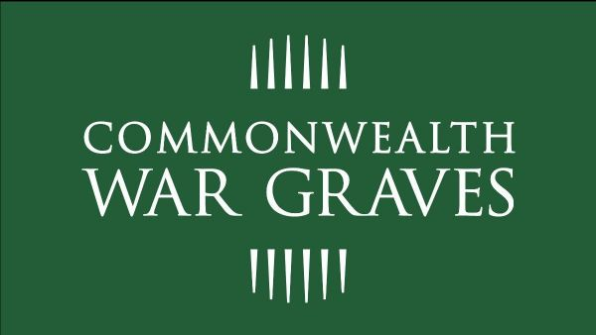
Foundation Office Admin Volunteer
Volunteer Role Description
Project Description
The Commonwealth War Graves Foundation (CWGF) aims to engage and educate people – especially the young – with the work of the Commonwealth War Graves and the inspiring stories of the men and women who died whilst fighting in the two World Wars.
Through our innovative educational activities, public events and outreach programmes, we want to educate everyone from school groups to world war buffs, amateur historians or just those interested in learning more about the names on their local war memorial.
About the Role
As a Foundation Office Admin Volunteer, you will provide in person support at our Head Office in Maidenhead. Working closely with our team, you will be responsible for the smooth running of our physical membership and donation mailouts.
What are the primary tasks for the role?
Tasks may include but are not limited to
- Carry out fulfilment and shipping of our welcome membership packs, any other membership and donation materials, as well as mailings to our Trustees.
- Ensure dispatch of materials to participants over the course of our virtual fundraising events.
- Maintain all relevant databases relating to postage and dispatch.
- Complete regular stock counts of materials.
- Conduct research for potential grant applications with our Director of Fundraising.
- Provide further support to our Volunteer and Public Engagement teams at peak times throughout the year, such as new volunteer recruitment.
- Develop your skills by becoming a For Evermore Volunteer Moderator, who review online submissions to our virtual stories portal.
What commitment will I need to make?
- To commit to volunteer for a minimum of 1 days per week, or up to 4 days per month, at the Maidenhead office. This would be on a Tuesday each week.
- Some tasks may be possible to complete from home. Access to a computer or laptop at home is required.
What skills and experience are required?
- High levels of attention to detail and accuracy
- Strong organisational skills and time management
- You must have good IT skills which include
  - being able to use and have access to the internet
  - Use of Microsoft Excel and Teams
  - being able to carry out online research
- An interest in and understanding of the work of the CWGC
- A willingness to undertake core mandatory CWGC Volunteer training modules
What will volunteers receive?
- Being part of a team, whose role is to share the stories of those commemorated by the Commonwealth War Graves Commission.
- Opportunity to gain administrative experience.
- Training and mentoring to help you learn about the CWGC and CWGF, and progress your skills.
- Access to our volunteering e-newsletter, and regional events to meet other volunteers.

Volunteers are an essential and appreciated part of our organisation.

We are delighted that you would like to become a Foundation Office Admin Volunteer for the CWGC.

We look forward to hearing from you soon.

